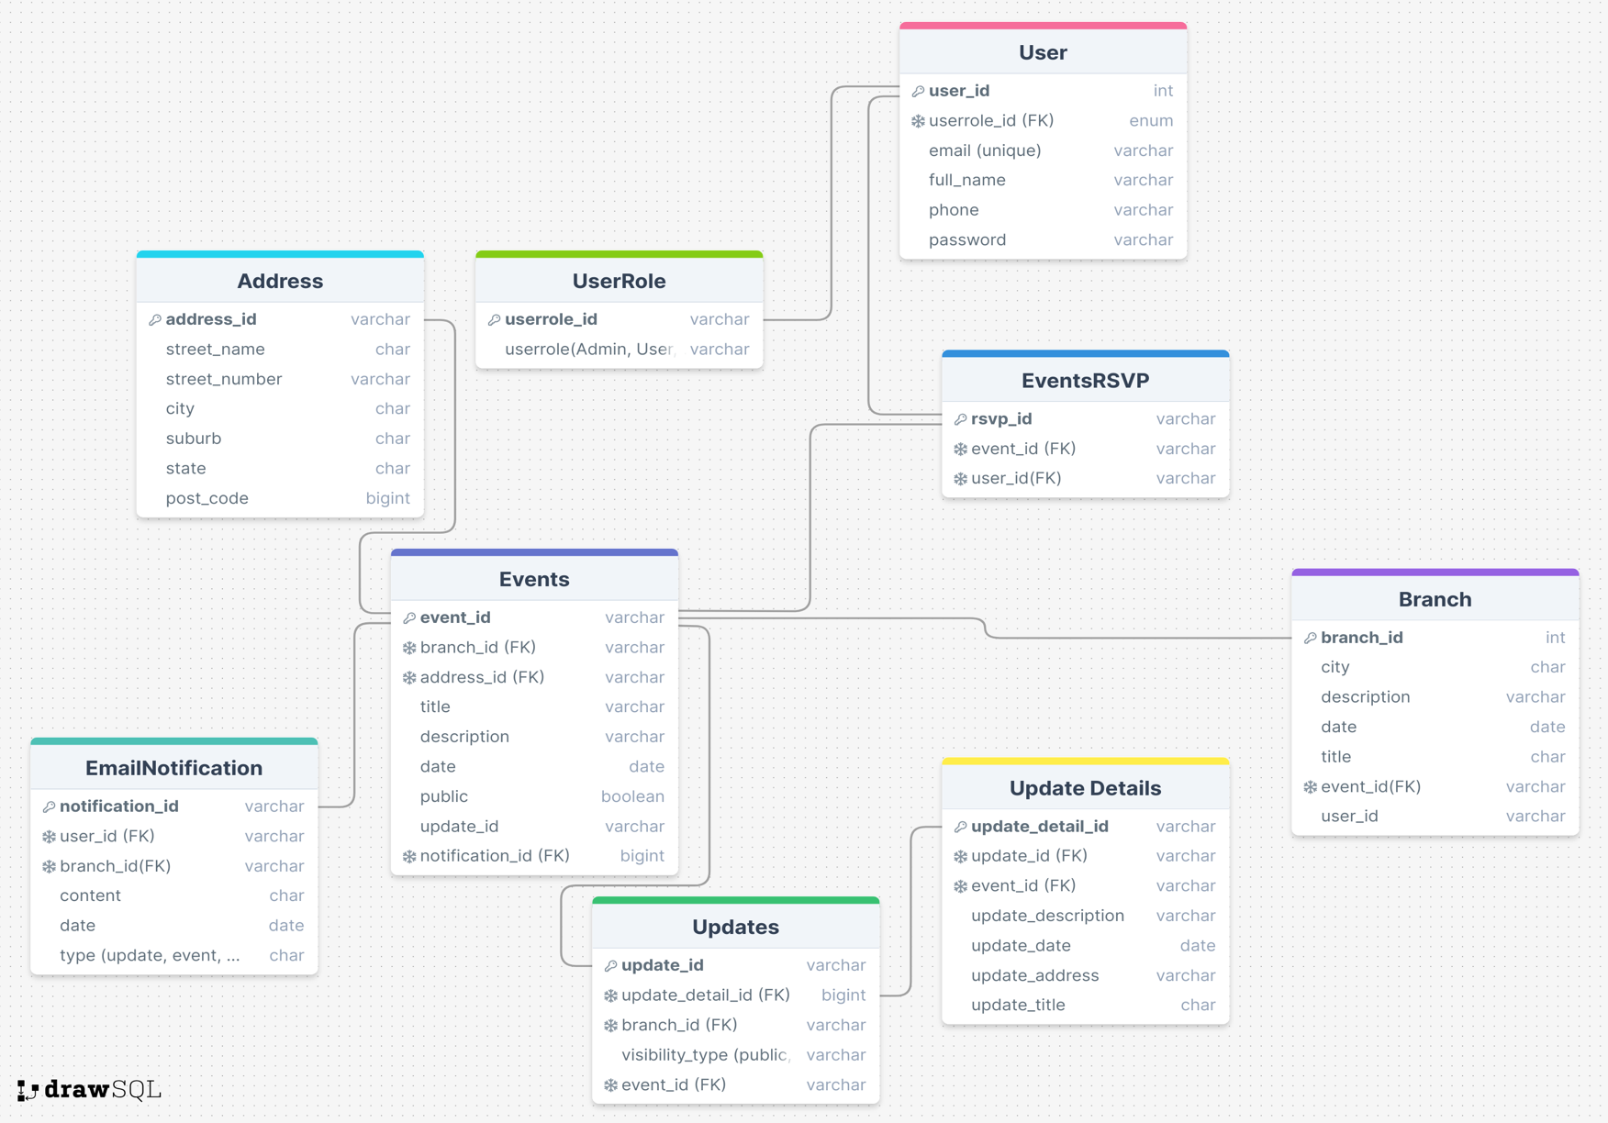

One to One Relations:
- One Event can only have One Address

One to Many Relations:
- Each user can have multiple roles (admin can make user managers), but multiple roles cannot be assigned to one user.
- One branch can host many events but many events cannot be part of the same branch (like event in Adelaide can’t be part of a Brisbane branch)
- One user can have many notifications
- One update can have many update details

Many to Many Relations:

- Users can be associated with many branches, and many branches can have many users.
- Users can RSVP to many events and Events can have many RSVP
- Updates can be part of many branches and many branches can have many updates.

